Art & Design, Reimagined: Nottingham Trent University
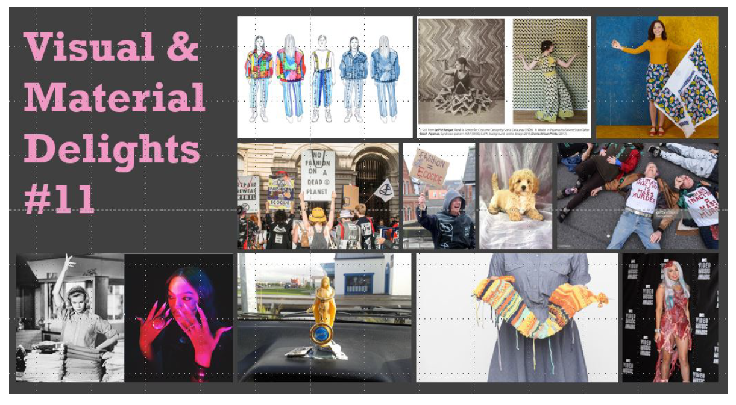
Like most other institutions across the world, the School of Art & Design at Nottingham Trent University (NTU) found itself in the punishing position of moving the entirety of its higher education content and delivery into the online environment – in a week. As a School, we delivered our five-year digital development plan across five-working days. Sounds impressive when you put it like that, however, arts-based subjects within a heavily making-focused discipline, do not readily transfer to the online environment quite so easily.

When the Covid-19 crisis emerged, and we were forced into the difficult position of shifting to emergency remote learning, a discipline known for its strength of community and creativity, once more evidenced its aptitude for sourcing practical and creative solutions. The enormity of this task was managed through the incredible collaborative commitment of our academics, our technicians and the administrative teams that support them. Focusing upon ensuring that we repositioned ourselves to offer the best access possible for our students, with an as-close-to-usual learning experience, all within the closely-confined parameters of the UK Coronavirus lockdown period. No mean feat. This has represented a significant challenge, but impressive collaborative practice has emerged from this reimagined space, much of which, we are intending to carry forward into our preparation for re-entry into a brave new post-Covid world.

This has included scheduled course team ‘huddles’ and the development of an online Culture Club, where students and staff come together around shared social experiences. Pastoral support has been intentionally foregrounded, both formally and informally, as we have adjusted to a new mode of learning and engagement, with online social activities featuring as a core part of our community and wellbeing offer. From an academic perspective, departmental staff support networks and best practice sharing spaces, through Microsoft Teams, have become a standard feature across the last few weeks, while an adjusted learning experience has been delivered within the academic environment through timetabled online live masterclasses, lectures, workshops, seminars and tutorials, using Teams and Panopto to enable both synchronous and asynchronous engagement. Class presentations have been delivered live using the screen sharing capacity of Teams, while practice-based tutorials have been delivered in an online face-to-face format, and technical demonstrations, particularly around our CAD offer, have been revisioned for virtual delivery.

Highlights worthy of celebration includes the strength of online course community that our courses have maintained from the start of the Covid-19 isolation period. We have seen some real innovations in our virtual transition, including the delivery of our School’s Visual and Material Delights Symposium (April 2020). Running on campus for a decade, the symposium made its electronic debut in its 11th year, with presentations scheduled online, each with an associated live discussion forum. This not only enabled simultaneous engagement, but also encouraged enhanced accessibility, as well as post-session collaboration and conversation. The symposium itself is designed to encourage cross-year, cross-discipline and cross-institution engagement around all aspects of visual culture, all of which were successfully translated to the online space.

Collaborative engagement with live industry partners has continued through paid student-led project design in the form of a departmental rebranding and identity creation exercise, including a reimagination of the physical and digital working space of the NTU Employability team. The project is currently being co-delivered in partnership with the School, Level 6 Graphic Design students, the university’s Employability and Marketing teams, as well as Nottingham’s global fashion retail design agency, Waste Studios, along with the guidance, mentoring and direction of their Founder and Creative Director. While our students relocated initially to set up in Waste Studio’s city centre headquarters, the students, staff and industry partners developed a creative and critical online space that was responsive to the present needs of the lockdown period, and will shape the way they work collaboratively in the now and near future.

In the quieter cultural climate, our Costume Design and Making students have seen the benefit of theatre and film workers supporting us in the delivery of online guest lectures ranging from award winning theatre designer, Lez Brotherston (Matthew Bourne – New Adventures ballet), to Mervyn Miller (Creative Associate for the National Theatre’s War Horse), and Will Tuckett (Royal Ballet and English National Ballet). The Nottingham Creative Quarter have also been supporting our Fashion Management students through hosting online discussions with alumni to share their knowledge of how companies within the sector have been rising to the dilemmas posed by Covid-19, as well as offering insights into how this is shaping the renewed approach of businesses within the current climate.

The issue of remote access during lockdown has been a recurrent challenge across all of our courses, in particular for those areas where specialist equipment is a necessity. In these instances, the resourcefulness of our technicians, and support of our professional services, has meant that we have been able to find creative solutions to support the development of our students’ practical work. Our innovative technical staff were able to support a remote access ‘fix’ to access kit that would otherwise be sitting as an unused School resource during the lockdown period. This meant that students who needed access to powerful computers, to be able to render their digital experiments when working with moving image and 3D renders, have been able to continue to work on their projects from the safety of their own homes.

Through strategic thinking, collegiate collaboration, and equal measures of enthusiasm and determination, we have found new ways of working with and supporting our students. Covid-19 may have forced us into isolation, but it has inspired our collaborative creativity in new and sometimes surprising ways. Art and Design, Reimagined.

